**Table Content**

**Introduction 1**

**Generation of RSA Key Pair 1**

**Encryption and Decryption 1**

**RSA Analysis 1**

**References.**

# Introduction

RSA cryptosystem is one the initial system. It remains most employed cryptosystem even today. The system was invented by three scholars **Ron Rivest, Adi Shamir,** and **Len Adleman** and hence, it is termed as RSA cryptosystem.

RSA algorithm is a public key encryption technique and is considered as the most secure way of encryption.

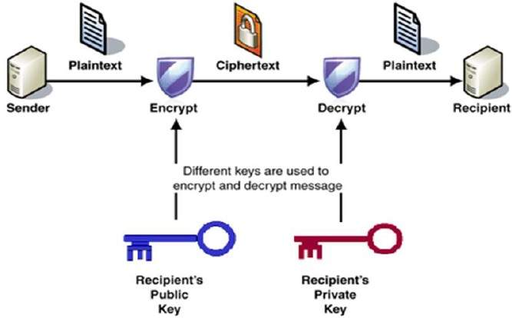

#### Algorithm

The RSA algorithm holds the following features −

* RSA algorithm is a popular exponentiation in a finite field over integers including prime numbers.
* The integers used by this method are sufficiently large making it difficult to solve.
* There are two sets of keys in this algorithm: private key and public key.

We will see two aspects of the RSA cryptosystem, firstly generation of key pair and secondly encryption-decryption algorithms.

# Generation of RSA Key Pair

Each person or a party who desires to participate in communication using encryption needs to generate a pair of keys, namely public key and private key. The process followed in the generation of keys is described below −

* **Generate the RSA modulus (n)**
  + Select two large primes, p and q.
  + Calculate n=p*q. For strong unbreakable encryption, let n be a large number, typically a minimum of 512 bits.
* **Find Derived Number (e)**
  + Number **e** must be greater than 1 and less than (p − 1)(q − 1).
  + There must be no common factor for e and (p − 1)(q − 1) except for 1. In other words two numbers e and (p – 1)(q – 1) are coprime.
* **Form the public key**
  + The pair of numbers (n, e) form the RSA public key and is made public.
  + Interestingly, though n is part of the public key, difficulty in factorizing a large prime number ensures that attacker cannot find in finite time the two primes (p & q) used to obtain n. This is strength of RSA.
* **Generate the private key**
  + Private Key d is calculated from p, q, and e. For given n and e, there is unique number d.
  + Number d is the inverse of e modulo (p - 1)(q – 1). This means that d is the number less than (p - 1)(q - 1) such that when multiplied by e, it is equal to 1 modulo (p - 1)(q - 1).
  + This relationship is written mathematically as follows −

ed = 1 mod (p − 1)(q − 1)

The Extended Euclidean Algorithm takes p, q, and e as input and gives d as output.

#### Example

An example of generating RSA Key pair is given below. (For ease of understanding, the primes p & q taken here are small values. Practically, these values are very high).

* Let two primes be p = 7 and q = 13. Thus, modulus n = pq = 7 x 13 = 91.
* Select e = 5, which is a valid choice since there is no number that is common factor of 5 and (p − 1)(q − 1) = 6 × 12 = 72, except for 1.
* The pair of numbers (n, e) = (91, 5) forms the public key and can be made available to anyone whom we wish to be able to send us encrypted messages.
* Input p = 7, q = 13, and e = 5 to the Extended Euclidean Algorithm. The output will be d = 29.
* Check that the d calculated is correct by computing −

de = 29 × 5 = 145 = 1 mod 72

* Hence, public key is (91, 5) and private keys is (91, 29).

# Encryption and Decryption

Once the key pair has been generated, the process of encryption and decryption are relatively straightforward and computationally easy.

Interestingly, RSA does not directly operate on strings of bits as in case of symmetric key encryption. It operates on numbers modulo n. Hence, it is necessary to represent the plaintext as a series of numbers less than n.

#### RSA Encryption

* Suppose the sender wish to send some text message to someone whose public key is (n, e).
* The sender then represents the plaintext as a series of numbers less than n.
* To encrypt the first plaintext P, which is a number modulo n. The encryption process is simple mathematical step as −

C = Pe mod n

* In other words, the ciphertext C is equal to the plaintext P multiplied by itself e times and then reduced modulo n. This means that C is also a number less than n.
* Returning to our Key Generation example with plaintext P = 10, we get ciphertext C −

C = 105 mod 91

#### RSA Decryption

* The decryption process for RSA is also very straightforward. Suppose that the receiver of public-key pair (n, e) has received a ciphertext C.
* Receiver raises C to the power of his private key d. The result modulo n will be the plaintext P.

Plaintext = Cd mod n

* Returning again to our numerical example, the ciphertext C = 82 would get decrypted to number 10 using private key 29 −

Plaintext = 8229 mod 91 = 10

# RSA Analysis

The security of RSA depends on the strengths of two separate functions. The RSA cryptosystem is most popular public-key cryptosystem strength of which is based on the practical difficulty of factoring the very large numbers.

* **Encryption Function** − It is considered as a one-way function of converting plaintext into ciphertext and it can be reversed only with the knowledge of private key d.
* **Key Generation** − The difficulty of determining a private key from an RSA public key is equivalent to factoring the modulus n. An attacker thus cannot use knowledge of an RSA public key to determine an RSA private key unless he can factor n. It is also a one way function, going from p & q values to modulus n is easy but reverse is not possible.

If either of these two functions are proved non one-way, then RSA will be broken. In fact, if a technique for factoring efficiently is developed then RSA will no longer be safe.

The strength of RSA encryption drastically goes down against attacks if the number p and q are not large primes and/ or chosen public key e is a small number.